

Name : Achama Rajentheran

Login ID : @oasis-portal.com

Course title : Executive Diploma in Business and Hospitality Management

Subject Code : BHM04 Tourism and Hospitality

Submitted date: **11 September 2017**

**Table of Contents**

|  |  |  |
| --- | --- | --- |
| **No** | **Details** | **Page** |
| 1 | Executive Summary | 2 |
| 2 | Introduction | 3 |
| 3 | Assignment Question | 4-11 |
|  | Question 1 |  |
|  | Question 2 |  |
|  | Question 3 |  |
|  | Question 4 |  |
| 4 | Conclusion | 12 |
| 5 | References | 13 |

**EXECTIVE SUMMARY**

In my assignment I’m going to talk about Tourism and Hospitality and describe about the Tourism and Hospitality and relevant with examples. Moreover there will be explain about Hospitality Industry based on my own understanding .Hence the assignment also provide the introduction about tourism and the type of tourism categories in a detail based on my understanding. And I’m also providing the relevant example. Than I’m also going to give a clear definition of tourism. Furthermore, in my assignment also will be explain about the concept of Lodging and Accommodation in Hospitality Industry .Lastly I’m going to explain about the Entertainment Industry in Hospitality Management and will relevant example according to the sub-heading.

**Introduction**

What is tourism? Tourism is a collection of activities, services and industries that delivers a travel experience. Tourism is the temporary short-term movement of people to destinations outside the places where they normally live and work, and their activities during their stay at those destinations.

The hospitality industry is a part of large enterprise known as travel and tourism industry. The travel and tourism is a group of business with one goal in common providing necessary and desired products and services to customers and travelers.

Tourism and Hospitality industry is reputed to be the world largest industry. Its revenues support a significant proportion of the economies of many nations and it is one of the largest employers worldwide. Its contribution to gross nation product, employment and regional development are well documented and unlike many others sectors ,it is forecast to grow in importance in the coming decades as leisure time increase.



Assignment Questions

**Q1:** Define the Tourism and Hospitality. Explain your understanding about Hospitality industry.

Tourism is a short term movements when someone goes to a destination outside of where they usually live or work. The activities they do while they are at travelling perspectives. These include tourist themselves, accommodation, organization, and transportation, educational organizations, government agencies.

Hospitality is the relationship between guest and hosts or friendly acts or practices. Hence this includes reception and entertainment of guests, visitor or foreigners, resorts, special events and others service for travelers and tourists

Tourism and Hospitality industry provides customer’s service to travelers and foreigners. Hotels, motels accommodations or businesses providing transitional or short stay accommodations with or without food. The hospitality industry comprises a wide range of categories in the service industry that includes accommodation, restaurant, event planning and transportation .The hospitality and tourism industry is diverse and includes many locations including parks, food and house.

.

**Q1: Explain about Hospitality industry**

The hospitality industry is one of the main industries in this world and this is the relationships between guest and hosts. Hospitality also involves showing respect for their guest. Hence hospitality industries have a lot of sectors.

The first sector is lodging accommodation this sector of the hospitality industry features a gamut from luxurious hotels to lavish resort and campground

The second sector is food and beverage is a famous industry in hospitality industry. It can range from something as simple as a bistro all the way to a high end restaurants and every catering establishment. There got a lot food categorize for food service industry for example catering businesses, full service restaurant’s and quick service establishments.

The third sector is travel and tourism it is a vast sector of the hospitality industry with several key players across the globe mostly it include trains, airlines and several crew members in their service.

The fourth sector is entertainment industry it is most important sector in hospitality industry because without entertainment activities it’s possible to enjoying our business or holiday

The fifth sector is timeshare in this scheme, people either individuals or parties own the rights to a place for a specific time period during a year. There are many places which can own for the time being under the timeshare rules for example is convention centers and villas and resorts.

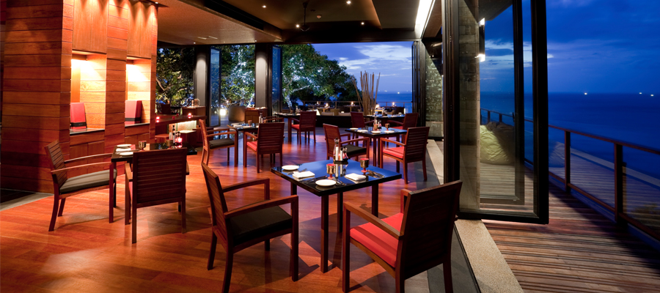

**Q2: Brief on different type of tourism categories**

1. Religious tourism

Is one type of tourism where people got religious locations to follow the footsteps of their founder or to attend a religious ceremony Catholics, for example go on Pilgrimages in the Holy Land to experience the paths where Jesus walked.

2. Medical or Health tourism

Is a relatively new type of tourist activity where the main focus of the travel is improving one health, physical appearance. For instance certain countries promote the expertise of their doctor and surgeons in the field of cosmetic procedures to be done there. Medical tourism also incorporates aspects of recreation tourism where the patient goes to a relaxing gateway to recover from the procedure.

3. Adventure tourism

Is another type of tourism that is catered for those who want to do more than just visit regular tourist sites. These kind of trips involve challenging activities like rock climbing, mountain climbing and wild water rafting

4. Sports tourism

Sports tourism refers to travel which involves either viewing or participating in a sporting event staying apart from their usual environment. Sport tourism is a fast growing sector of the global travel industry. Normally these kinds of events are the motivators that attract visitors to visit the events like Olympic Games, FIFA World Cup

5. Leisure tourism

Tourist may travel to experience a change in climate and place and learn something new enjoy pleasant scenery or to know more about the culture of a destination

6.Cultural tourism

It is also called as heritage tourism. People are curious to know about foreign lands and their cultures. A culture is most important factors which attracts tourists to a destination. For example religions, fairs and festivals, customs traditions and dress.

7. Family

Family tourism involves the family unit and their participation in diverse forms of tourism activity. This includes visiting one relatives and friends for interpersonal reasons

8. Educational tourism

Educational tourism developed because of the growing popularity of teaching and learning of knowledge and the enhancing of technical competency outside of the classroom environment. The main focus of the tour visiting another country to learn about culture for example Study Tours.

9. Business tourism

The business travelers main motive for travel is work. Tourists visit a particular destination for various reasons pertaining to work such as attending a business meeting and meeting clients. Business tourism is popularly called as MICE(Meeting, incentives, conferences, and exhibitions)tourism.

**Define about the tourism**

Tourism is the temporary short term movement of people to destinations outside the places where they normally live and work and their activities during their say at those destination .Tourism is to visit different places and country for sightseeing.

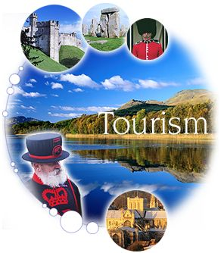

**Q3: Describe the lodging accommodation and types of hotel accommodation.**

**Lodging Accommodation**

This sector of the hospitality industry features a gamut from luxurious hotels to lavish resorts and campgrounds. Accommodation is an absolutely broad sector of the hospitality industry Aranging bed breakfast enterprise and hotels to other facilities that offer lodging services.

That got three main types of hotel and accommodation services.

**Lodging:** When people travel from one place to the other they need a place to sleep. A shelter which will keep them safe from the atrocities of nature. This results in people booking lodges and rooms for their stay.

**Suites:** Apart from general lodges to stay hotel sector offers luxury suites for the stay as well. Generally suites are suitable for formal sorts of staying and are much expensive compared to regular room services.

**Resorts:** The third type of accommodation which is popular among travellers is resorts. These bring you close to nature and give you a necessary break from your normal routines.

**Explain the types of hotel accommodations**

**Bed breakfast**

A bed and breakfast is a private home in which guests can be accommodated at night in private bedrooms. The owner or manager lives in the house or on the property. The public areas of the house, such as kitchen and lounge have either limited access for guests or are shared with the host family to some degree. The business may be run as a secondary occupation.

**Self-catering**

A self-catering establishment may be primarily one of the other accommodation types, but also offers dedicated self-catering facilities. The unit should feature a fully equipped kitchen to cater for the maximum people to be accommodated.

**Resort**

A spread out collection of single or double story accommodation units. Similar to a hotels in that it offers a wide range of facilities. Units may be rented and available on time share. A camping area may be included in the resort.

**Private home**

A private home not dedicated for full occupation of guests, but is a private house or apartment which is temporarily available for rental often during peak tourism seasons.

**Lodge**

A lodge is an accommodation facility which is located and designed to optimize the feelings of being close in touch with nature. The building style should feature natural materials and coloring such as wood, stone, and thatch. An outdoor experience should be offered at the lodge such as guided walks game drives.

**Hotel**

A hotel is generally the largest of all accommodation types. There is typically a common reception area and rooms generally open directly onto a hallway. The onsite restaurants and other accommodation types. Wide range of guest services is available such as room service. Hotels are often members of large hotels group and a similar accommodation experience may be available in different establishments within in group.

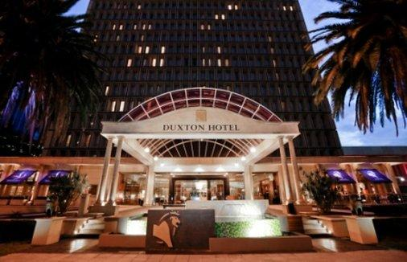

**Q4:Explain the importance of entertainment in this industry**

In today modern society entertainment industry play a important role in peoples life everyday. Entertainment industry will diverts people attention from their demanding lives in their leisure time. Usually a lot of entertainment will use at hotels ,lodge, accommodation and entertainment can take various like music, drama and movies. Hence entertainment also will give relaxing and a freshen mind or moment to tourist. Entertainment also will attract people to spend more time to the place they travel or stay.

**Examples of entertainment industry in Hospitality**

Some of the activities which can comes to entertainment are

Marina**:** Marinas are one of the most popular places to have party. People can get along with their friends for private yacht where can dance, play games and enjoy.

Sports and gaming: sports and gaming ia a basic things which people are looking for on their travel. For example casinos , swimming poll.

Nightclub: nightclub’s is most popular place around the world because people love to dance on their favorites song.

Bars: Bars is around a table and having a couples of drinks with friends is always a relaxing things. This is why bars make an important part of the entertainment sector of the hospitality industry.

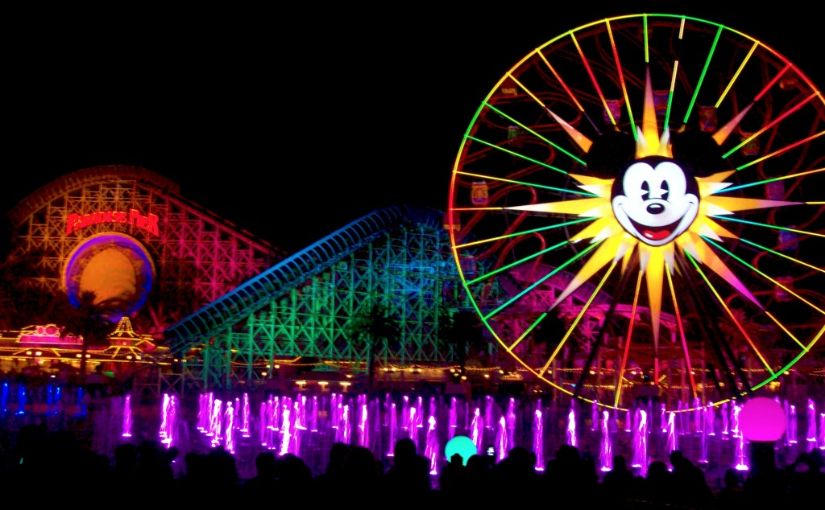

**Conclusion**

From the above assignment I have done it can be concluded tourism and hospitality is a important things in the world. I have learn about the different between tourism and hospitality and I also get know the importance of tourism and hospitality in this world. Lastly I get concluded that tourism and hospitality is a business success in the world and its provide many variety of service as well to building a relationship with customers and this assignment very useful to me to know more about tourism and hospitality

**REFERENCE**

https://www.google.com.sg/search?dcr=0&biw=1366&bih=662&q=entertainment+industry&oq=entertainment+ind&gs_l=psy-ab.1.0.0l4.701.2644.0.4420.4.4.0.0.0.0.200.368.3j0j1.4.0....0...1.1.64.psy-ab..0.4.364...0i67k1.VJrc1HiIcoI

https://www.google.com.sg/search?dcr=0&biw=1366&bih=662&q=tourism+industry+definition&oq=TOURISM+&gs_l=psy-ab.1.1.0i67k1l2j0l2.60182.65491.0.68066.27.16.0.0.0.0.132.1130.11j4.15.0....0...1.1.64.psy-ab..18.9.652...0i131k1.4Rz_IlDvKDQ

https://www.google.com.sg/search?dcr=0&biw=1366&bih=662&q=hospitality+industry+definition&oq=HOSP+definition&gs_l=psy-ab.1.3.0i7i30k1l4.48911.55278.0.58223.20.13.0.0.0.0.147.1102.9j4.13.0....0...1.1.64.psy-ab..11.9.840...0i67k1.AYzEyZT-N2M